Laxmi Charitable Trust’s
Sheth L.U.J College of Arts & Sir M.V. College of Science and Commerce
Department of Information Technology (B.Sc.I.T Semester V)
Applied Business Analytics
Tasks
Roll No.: T053 | Name: Nidhi Yadav
Class: TYIT | Batch: 2
Date of Assignment: 31-07-26 | Date/Time of Submission: 31-07-26
Extra Task:
Perform following questions using Retail.csv
Q.1 Write a Python program to:
Count the number of products in each Product Category.
Find the category with the highest sales.
Display the result using a bar chart.
Code & Output:
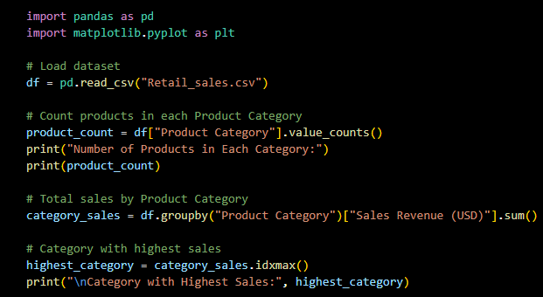
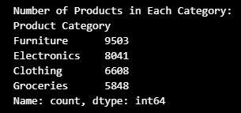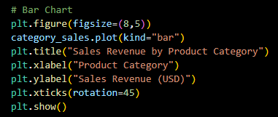
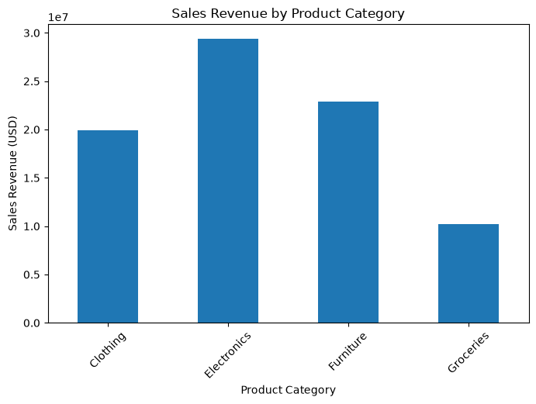
Q.2 Write a Python program to:
Calculate the total Sales Revenue for each Store ID.
Find the best-performing store.
Find the least-performing store.
Display the result using a horizontal bar chart.
Code & Output:
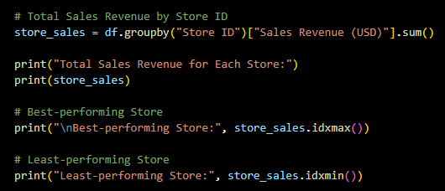
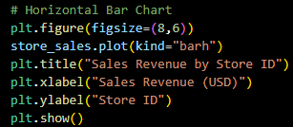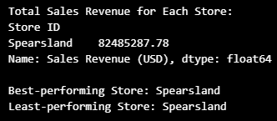
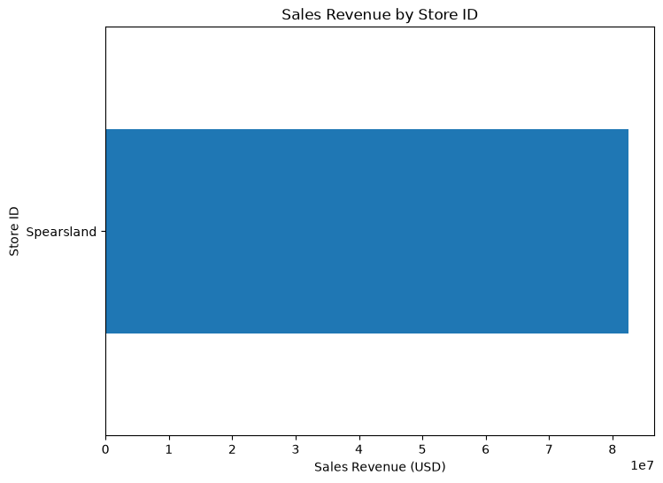

Q.3 Write a Python program to:
Calculate total Sales Revenue for each Store Location.
Identify the location with the highest sales.
Plot the results using a bar chart.
Code & Output:
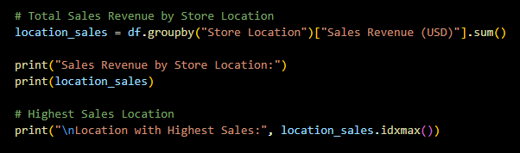
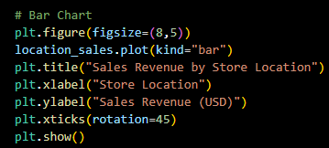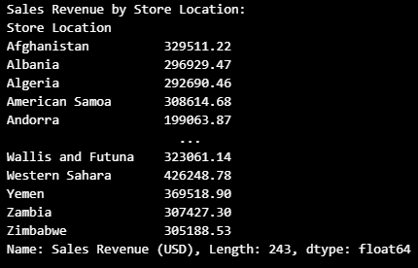

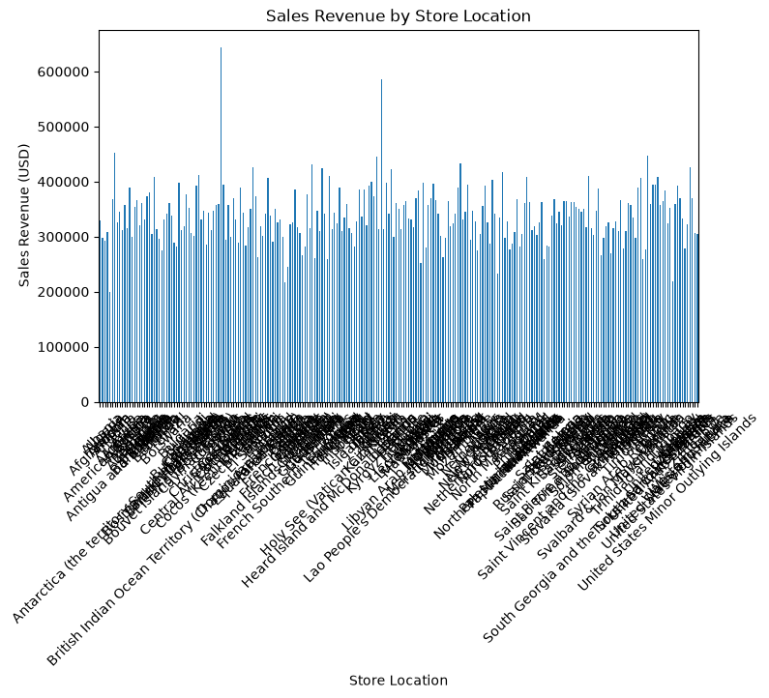
Q.4 Calculate the following descriptive statistics for the Units Sold column:
Mean, Median, Mode, Minimum, Maximum, Range, Variance, Standard Deviation
Code & Output:
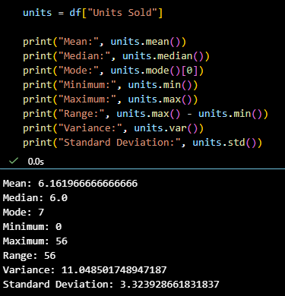
Perform following operations on Netflix.csv
Q.1 Create a Box Plot for the Release Year column.
Identify:Minimum value,Maximum value,Median,Presence of outliers
Code:
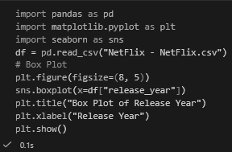
Output:
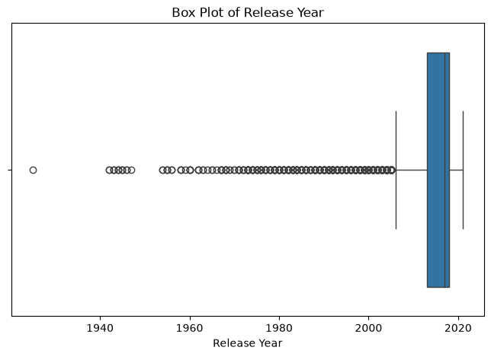
Q.2 Filter only Movies from the dataset.
Extract the numerical value from the Duration column (e.g., 90 min → 90).
Calculate:Mean, Median,Mode,Variance,Standard Deviation,for movie duration.
Code & Output:
